Timmi begins seeing Dr. Erica Gettis

Once in Louisville, Timmi and Charles needed to find a primary care physician. Dr. Erica Gettis at UofL Heath – Medical Center Northeast was recommended to them. Dr. Gettis’ office was also near their house, which was convenient. Timmi and Charles, ever together, both made appointments to see Dr. Gettis to establish care.
On October 14, 2021, Timmi saw Dr. Gettis for an initial visit. Below is Dr. Gettis’ note from that visit:
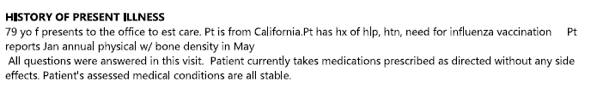
Under Timmi’s “social history,” Dr. Gettis noted that Timmi smoked cigarettes for 32 years and had quit in 1990:

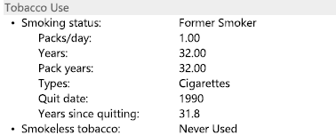

And, under Timmi’s “vital signs,” Dr. Gettis noted Timmi was a former smoker. Accordingly, Dr. Gettis knew, from her initial visit with Timmi, that Timmi was a former smoker. Dr. Gettis ordered lab work and asked to see Timmi in follow-up for an annual physical in January. Timmi also received her flu shot that day.

On January 19, 2022, Timmi had her annual physical with Dr. Gettis. Dr. Gettis and Timmi discussed Timmi’s blood pressure management and Timmi had some ear cerumen removed. Timmi also received her pneumonia vaccine.

On January 21, two days later, Timmi called Dr. Gettis’ office because she noticed the pneumonia shot she received at her annual physical was not recorded. This is an example of just how hypervigilant Timmi was about her health and any follow-up she required.

On February 23, 2022, Timmi saw Dr. Gettis and told her she was experiencing bilateral carpal tunnel pain. Timmi described tingling and a “fire feeling” in her fingers. Dr. Gettis referred Timmi to Kleinert Kutz.

On March 16, 2022, Timmi saw Dr. Huey Tien at Kleinert Kutz. Dr. Tien recommended that Timmi have bilateral carpal tunnel release surgery.

On July 1, 2022, Timmi called Dr. Gettis’ office. She needed Dr. Gettis to complete the surgery clearance forms from Kleinert Kutz’s office so she could have her carpal tunnel surgeries:
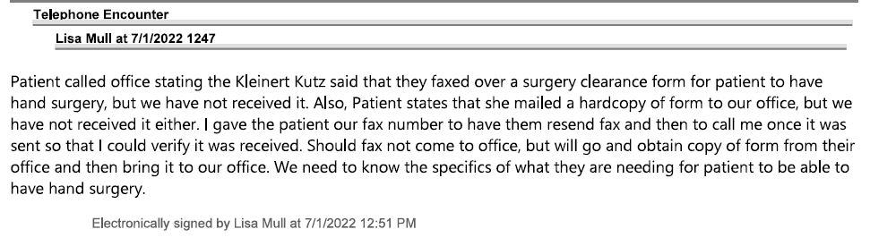

Based on this note, Dr. Gettis’ office claimed they did not receive either the fax from Kleinert Kutz or the copy Timmi mailed to them. Timmi offered to go to Kleinert Kutz, pick up the form, and hand deliver it to Dr. Gettis’ office if the fax did not go through.

However, the fax must have finally gone through or Timmi hand-delivered the form because, two weeks later, on July 15, 2022, Timmi saw Dr. Gettis to get cleared for her carpal tunnel surgery, which was scheduled for August 4, 2022. Dr. Gettis noted:

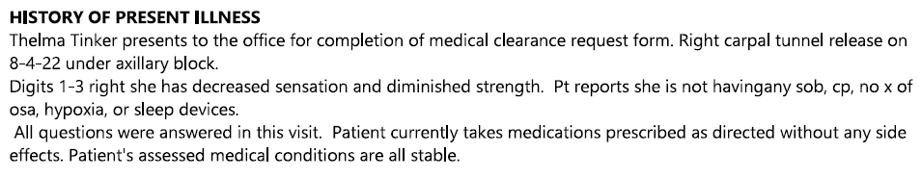

Timmi had an EKG and XR chest 2 views and, under “discussion summary,” Dr. Gettis noted:

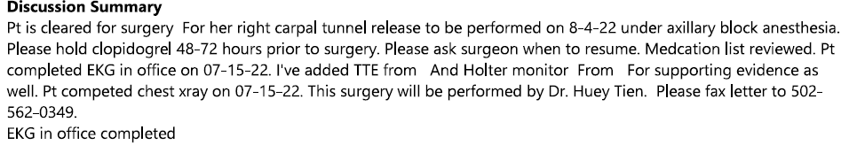

Notably, the chest x-ray revealed a 2.3 cm concerning pulmonary opacity:

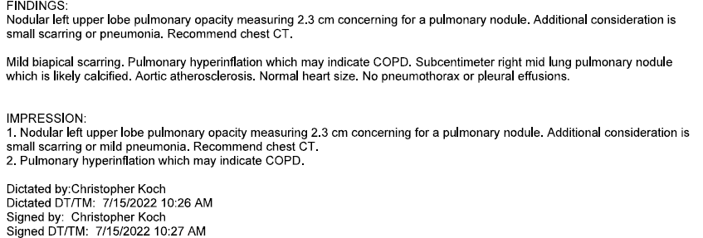

On July 19, 2022, Dr. Gettis wrote a note for Timmi to be told the results and that she needed a follow-up chest CT:

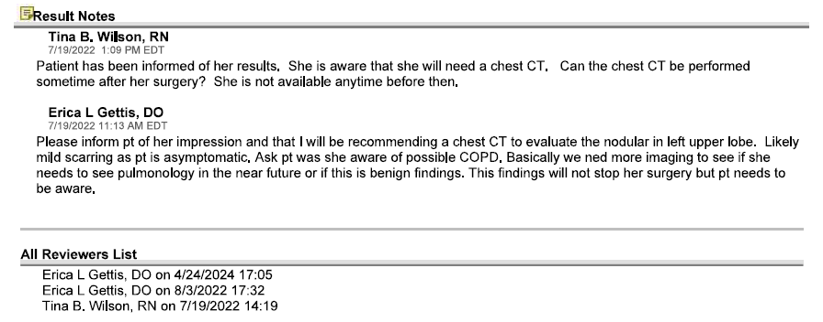

On July 19, 2022, Dr. Gettis ordered the CT chest. In her order, she indicated the CT was needed because of a lung nodule > 8mm and abnormal x-ray. Dr. Gettis asked for the results to be auto-released to her, but for the results to be delayed by 3 days before Timmi could see them. The reason given: “Reasonable likelihood of causing patient harm; Comment – rule out cancer”:

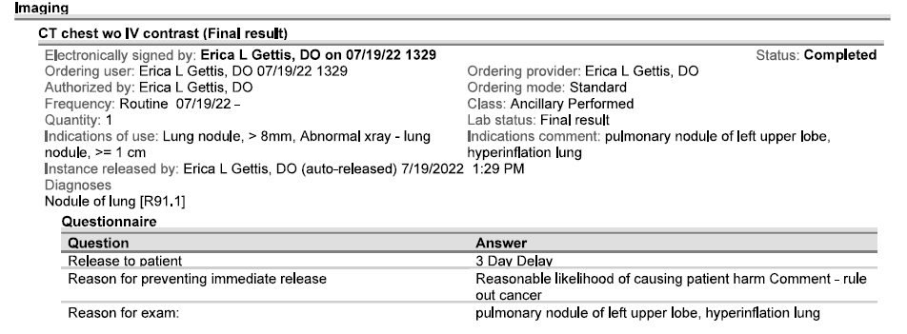
Without delay, Timmi scheduled the recommended CT chest and had it done on July 21. The CT chest confirmed a pulmonary nodule and the radiologist recommended a PET CT be performed:

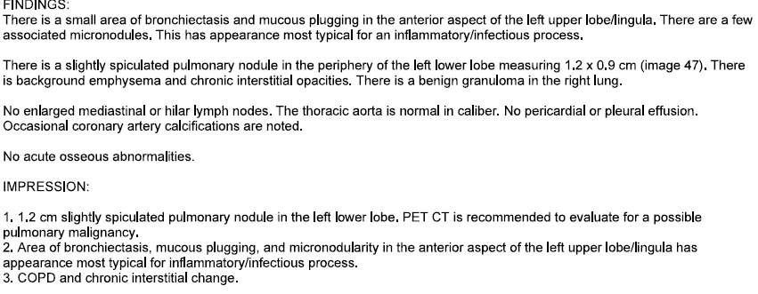

While Dr. Currier dictated and signed his report on July 21, Tina Wilson with Dr. Gettis’ office did not acknowledge the report until August 8 and Dr. Gettis did not acknowledge the report until April 24, 2024:

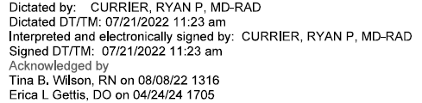←

Needless to say, nobody called Timmi from Dr. Gettis’ office to tell her about the results of her July 21 CT or to tell her about the need for a PET.

On August 4, 2022, Timmi had her hand surgery with Dr. Tien without complications.

On August 5, 2022, the day after her surgery, Timmi saw the recommendation from Dr. Currier in her MyChart to get a PET scan. She called Dr. Gettis’ office and asked why Dr. Gettis had not called her with the results and let her know about the recommended PET scan:

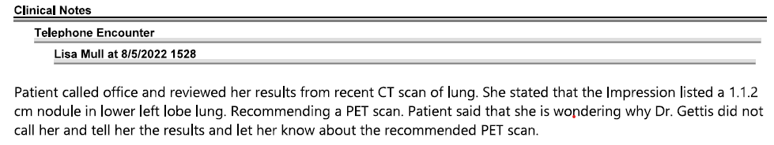

In response, Tina Wilson sent a message: “Please advise.” Dr. Gettis responded on August 8 to call the patient and ask Rachel who is working orders for Lisa:
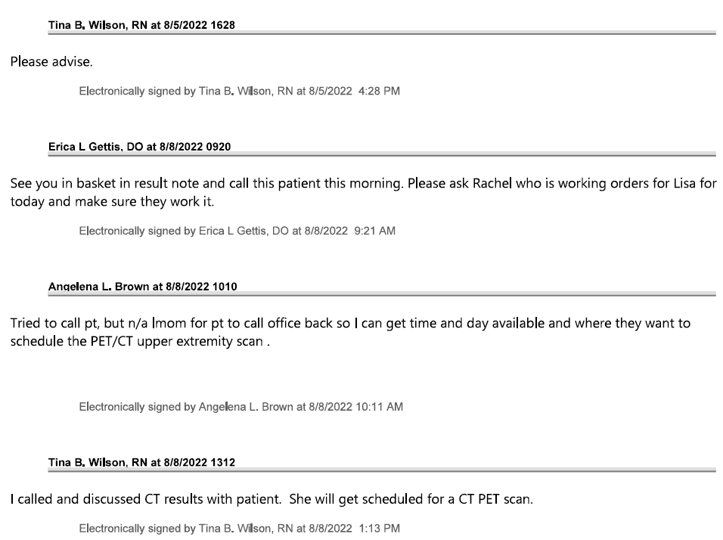
Based on the above, Tina Wilson spoke with Timmi about the results and the need for a PET scan. However, in the below note, written before Tina Wilson’s note, Dr. Gettis wrote that patient reported “this has been present before” and “not new.”

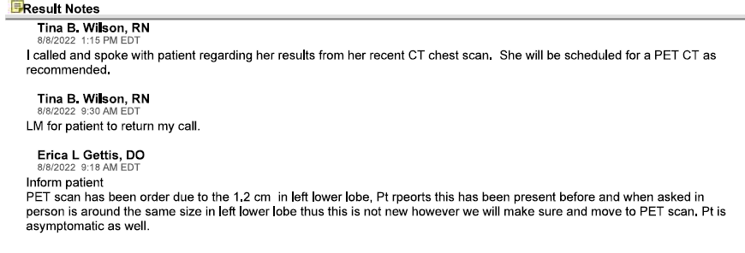
It is unclear whether Dr. Gettis is referring to a previous conversation she had with Timmi about this nodule or whether Tina Wilson and Dr. Gettis both spoke with Timmi. Regardless, Dr. Gettis agreed the nodule needed to be evaluated and ordered the PET scan:
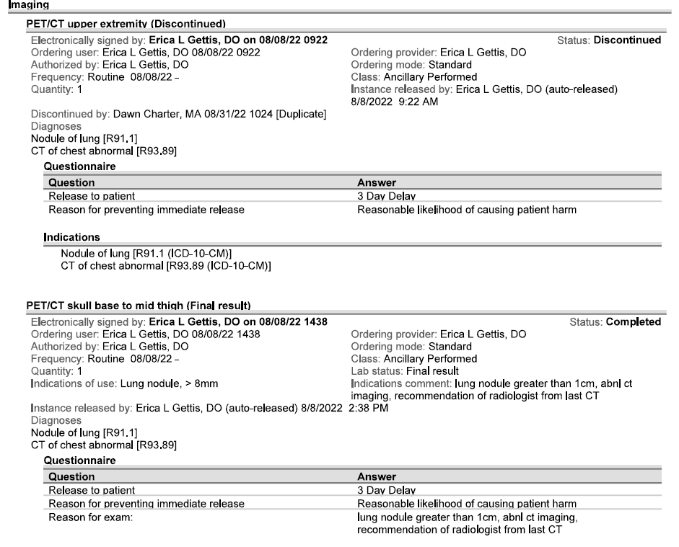

Ever the dutiful patient, on August 15, 2022, Timmi had the PET CT. The PET scan was read by radiologist, Dr. Robert Aria, whose impressions are below:

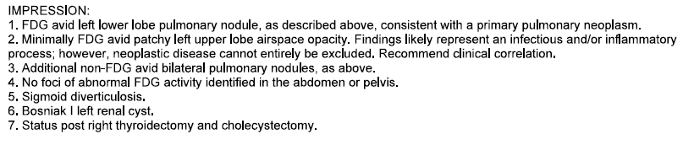
To someone with medical training, this is a very concerning result. To a layperson, however, this note does not state that Timmi has cancer or needs to have a specific test or needs to see an oncologist. Dr. Gettis and Dr. Aria – the ones with medical training and the ones responsible for Timmi’s care - never told Timmi about these results or what they meant. Egregiously, Dr. Gettis did not even acknowledge the results of the PET until April 24, 2024 – almost 2 years later:

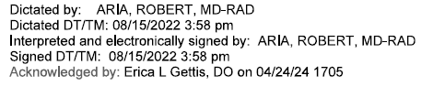
←

In the months that followed, Timmi went about life having no idea that she had a pulmonary nodule in need of treatment.

Yet, Dr. Gettis and her office had other, multiple opportunities to notice the PET result in Timmi’s chart and alert Timmi to the results, like on November 25, 2022, when Timmi needed a refill for her Zocor. Or, on December 12, 2022, when Timmi requested a refill of her Norvasc and Cozaar. Or, on February 2, 2023, when Timmi needed a refill of her Plavix, Hygroton, and Synthroid. Or, on April 11, 2023, when Timmi called and requested an order for her screening mammogram. Or, on April 13, 2023, when Timmi saw Nakesha Mansfield, NP in Dr. Gettis’ office for ear cerumen removal. Or, on April 21, 2023, when Timmi had her annual physical, which was with Nakesha Mansfield, NP. Or, on April 26, 2023, when Timmi’s mammogram results were sent to Dr. Gettis. Or, on May 22, 2023, when Timmi needed a refill. Or, on June 4, 2023, when Timmi needed refills. Or, on July 28, 2023, when Timmi needed refills. Or, on November 18, 2023, when Timmi needed a refill. Or, on December 7, 2023, when Timmi needed a refill. Or, on January 4, 2024, when Timmi left a message on MyChart for Dr. Gettis:
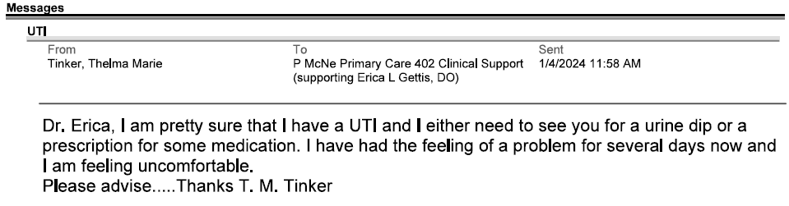

In response to this message, Tina Wilson called Timmi and told her to go to urgent care. But, once again, nobody told her about the results of her PET scan:

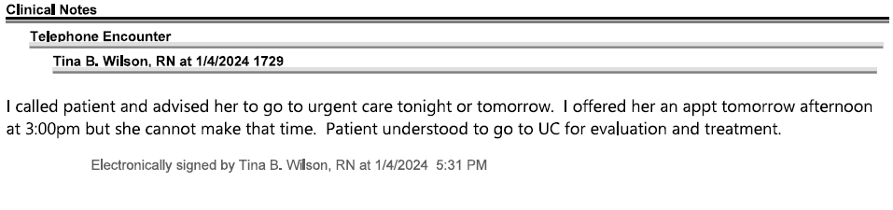 This trend continued on January 16, 2024, when Timmi called for a refill. Or, on February 8, 2024, when she needed a refill. Or, on April 5, 2024, when she needed refills. Or, on April 8, 2024, when she needed a refill. Or, most egregiously, on April 24, 2024, when Timmi saw Dr. Gettis for her annual physical. You see, that is the same day that Dr. Gettis went back and acknowledged the results of the August 15, 2022 PET scan as evidenced below:


Despite acknowledging the results on April 24, 2024, Dr. Gettis still did not tell Timmi about the results. And, Dr. Gettis made absolutely no mention of these results in her notes from that day when she saw Timmi. In fact, Dr. Gettis wrote “[t]here are no diagnoses linked to this encounter.”:

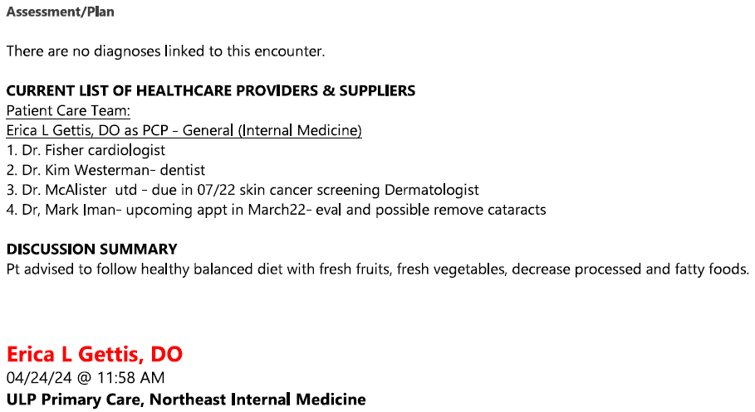

Timmi continued not to be told about her PET scan results on April 29, 2024, when she had her mammogram, and on April 30, 2024, when she requested a refill of her Zocor.

On May 9, 2024, less than two weeks after her April 24, 2024 annual physical with Dr. Gettis, Timmi had to be taken to the ER. Timmi thought she may have Covid, as she felt fatigued and short of breath. Instead of Covid, Timmi and her family learned that Timmi had cancer. More shockingly, they learned the August 15, 2022 PET scan revealed this cancer, but Dr. Gettis, Dr. Aria, and UofL Health had never told her:

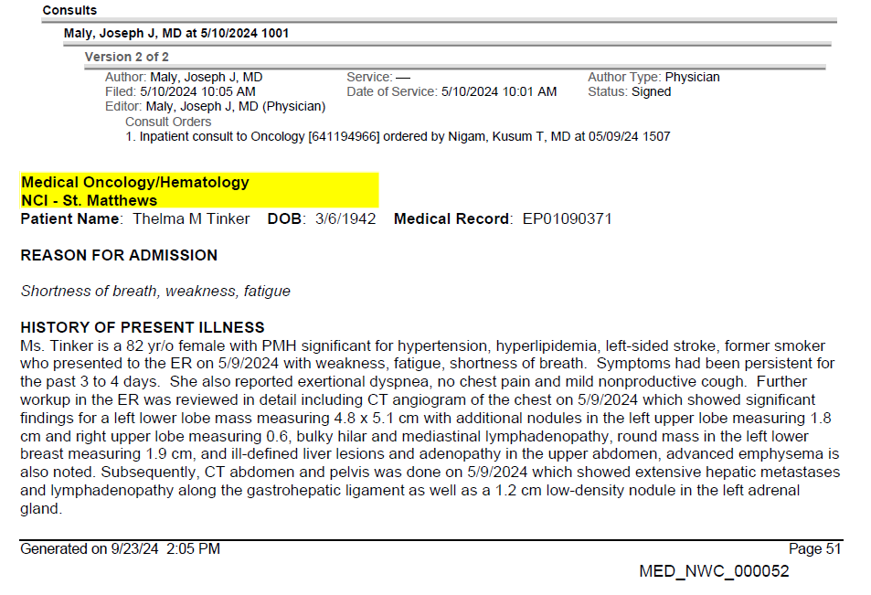
.
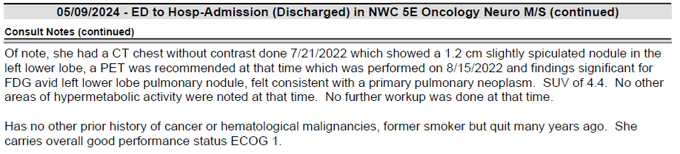

The oncologist, Dr. Maly, noted that the August 15, 2022 PET scan was significant for FDG avid left lower lobe pulmonary nodule consistent with a primary pulmonary neoplasm and no other areas of hypermetabolic activity were noted at that time. He had compared the May 9 CT to Timmi’s previous scans in 2022. This was treatable cancer – if treated in August 2022! Dr. Maly explained that the nodule in Timmi’s lung had grown and had spread to her liver and possibly the kidney. He wanted to biopsy the liver to determine the next steps. After he left, Monica asked her mom what she was thinking. Timmi said, “well, I don’t want to have chemo, but I don’t want to die.” Arrangements were made for the biopsy to be performed in the coming days, Timmi had a brain MRI the next day, on May 10. Monica drove Timmi home from the hospital that night and, after getting her mom settled in the house, drove home crying.

